11.3: In the notation of Example 11.1, take the origin to be the point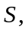 and let the child’s distance from this point be Then,
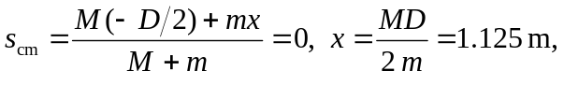
which is 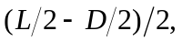halfway between the point and the end of the plank.

